**UV COLOURS OF ASTEROIDS IN THE SERENDIPITOUS OBSERVATIONS OF THE XMM-NEWTON OPTICAL MONITOR CAMERA.**

| Titulación:  **MÁSTER UNIVERSITARIO EN ASTRONOMÍA Y ASTROFÍSICA**  Curso académico:  **2022 – 2023** | Alumno/a:  **HEBRERO CASASAYAS PAU**  D.N.I: **43169324A** | Directores de TFM:  **ELENA RACERO PÉREZ,**  **IGNACIO DE LA CALLE PÉREZ**  Convocatoria:  **Segunda** |
| --- | --- | --- |

# 1 Index

**1 Index 1**

**2 Resumen 3**

**3 Summary 5**

**4 List of Acronyms 6**

**5 Introduction 7**

5.1 Scientific background 7

5.2 Previous work 8

5.3 XMM Newton 9

5.3.1 Optical/UV Monitor Telescope 11

5.4 Objective 14

**6 Methodology 15**

6.1 Candidates selection 15

6.2 Screening 16

6.2.1 Obtaining the observation data 18

6.2.2 Displaying the data 18

6.2.2.1 Trajectory indicators 20

6.2.2.2 Adjusting DS9 scale 21

6.2.3 Recording the analysis outcome 22

6.3 Photometry 26

6.3.1 Rectangular aperture (trail) photometry 28

6.3.2 Magnitude calibration 30

**7 Results & analysis 32**

7.1 Screening 32

7.2 Photometry 34

7.2.1 Obs. 110980101 - Lucubratio 35

7.2.2 Obs. 0302580701 - Chesneau 37

7.2.3 Obs. 0303561001 - Fredtreasure 38

7.2.4 Magnitudes and colours 39

7.3 Future work and improvements 40

**8 Bibliography 41**

**9 Annexes 44**

9.1 Candidate observations 44

9.2 Screening results 48

9.3 Detection images 52

9.3.1 Obs. 11098010 - Lucubratio 52

9.3.1.1 L Filter 52

9.3.1.2 B Filter 53

9.3.2 Obs. 0302580701 - Chesneau 54

9.3.2.1 L Filter 54

9.3.2.2 U Filter 54

9.3.3 Obs. 0303561001 - Fredtreasure 55

9.3.3.1 L Filter 55

9.3.3.2 U Filter 55

# 

# 2 Resumen

*(English version in section below)*

El presente documento expone el trabajo realizado como parte del Trabajo Fin de Máster del Máster Universitario en Astronomía y Astrofísica de la Universidad Internacional de Valencia: “UV COLOURS OF ASTEROIDS IN THE SERENDIPITOUS OBSERVATIONS OF THE XMM-NEWTON OPTICAL MONITOR CAMERA” (“COLORES ULTRAVIOLETA DE ASTEROIDES EN OBSERVACIONES SERENDÍPICAS DEL OPTICAL MONITOR CAMERA DEL XMM-NEWTON”).

El telescopio espacial de la Agencia Espacial Europea (ESA), XMM-Newton (X-ray Multi-Mirror Mission)[1], lanzado en 1999 ha realizado (y sigue realizando hasta la fecha) observaciones en longitudes de onda corta, centrándose sobre todo en rayos X y ultravioleta (UV). Éstas últimas llevadas a cabo por su telescopio óptico/UV: el XMM-OM (XMM-Newton Optical/UV Monitor Telescope). A lo largo de las últimas décadas, dicho instrumento se ha utilizado para la observación con carácter científico de objetivos específicos en el rango óptico y UV. No obstante, tal cantidad de observaciones a lo largo de los años abren la posibilidad a observaciones serendípicas (casuales, no intencionadas) de otros cuerpos celestes.

El objeto de este trabajo es el análisis de asteroides en dichas observaciones serendípicas. Está basado en el estudio previo realizado por la directora del TFM[2], donde se publicó un catálogo de observaciones que podrían haber capturado un asteroide en su campo de visión de forma inintencionada. En el presente trabajo se han analizado varias de estas posibles observaciones atendiendo al rango óptico/UV, procediendo a analizar fotométricamente aquellas que proporcionaban suficiente información.

En esta memoria se recogen no sólo los resultados del estudio, sino también la metodología seguida para llegar a ellos, tanto desde un punto de vista científico como práctico, desglosando cada una de las herramientas desarrolladas para facilitar (e incluso automatizar) el proceso.

# 3 Summary

*(Versión en español en la sección anterior)*

The present document outlines the work done as part of the Master Thesis for the Máster Universitario en Astronomía y Astrofísica of Universidad Internacional de Valencia: “UV COLOURS OF ASTEROIDS IN THE SERENDIPITOUS OBSERVATIONS OF THE XMM-NEWTON OPTICAL MONITOR CAMERA”.

European Space Agency’s (ESA) space telescope, XMM-Newton (X-ray Multi-Mirror Mission)[3], launched in 1999 has been performing (and continues to do so) observations in short wavelengths, focusing primarily on X-Ray y ultraviolet (UV) ranges. The latter are carried out by its optical/UV telescope: the XMM-OM (XMM-Newton Optical/UV Monitor Telescope). In the past few decades, said instrument has been used for the scientific observation of targets within the optical and UV ranges. However such a large amount of observations throughout the years open up the possibility of serendipitous (i.e. random, unintended) observations of other celestial bodies.

The purpose of this work is the analysis of asteroids captured in the aforementioned serendipitous detections. It is based on the previous work done by the Master Thesis director[4], where a catalogue of observations that could unintentionally contain an asteroid within their field of view was published. The present work analyses several of these observations, focusing on the optical/UV range, and proceeding to photometrically analyse those that provide enough data.

This Thesis gathers not only the results but also the process that has been followed to reach them, from both a scientific point of view as well a pragmatic one, breaking down each of the tools developed to ease (and even automate) the process.

# 4 List of Acronyms

| **Acronym** |  |
| --- | --- |
| API | Application Programming Interface |
| DS9 | SAOImageDS9 software |
| ESA | European Space Agency |
| FITS | Flexible Image Transport System |
| FoV | Field of View |
| HDU | Header Data Unit |
| HST | Hubble Space Telescope |
| HTTP | Hypertext Transfer Protocol |
| I/O | Input/Output |
| (XMM-Newton) OM | XMM-Newton Optical/UV Monitor Telescope |
| SSO | Solar System Object |
| (ESASky) SSOSS | (ESASky) Solar System Object Search Service |
| UV | Ultraviolet |
| (ESA) XMM-Newton | (ESA) X-ray Multi-Mirror Mission |
| XSA | XMM-Newton Science Archive |

# 

# 5 Introduction

## 5.1 Scientific background

In the past decades several asteroid classification systems have been published. These systems attempt at categorising asteroids based on their reflectance spectrum, that is, the spectrum of sunlight reflected off their surface. These classes and systems are important as they provide information regarding the composition of the asteroid’s surface (and potentially their internal composition too).

However, the Sun’s solar spectrum steeply drops at around 300 nm, making it very difficult for ultraviolet (UV) light reflected on the asteroid’s surface to be detected:

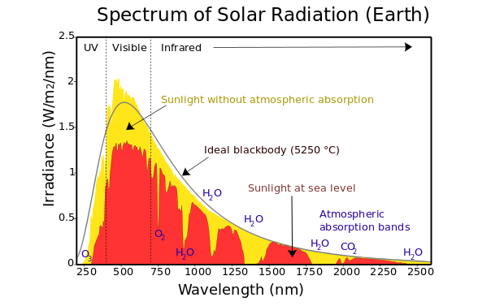

Sun’s solar spectrum from Earth[5].

This, in addition to the atmospheric UV absorption, have burdened the possibility of a large demographic study of asteroids in the UV range. As of 2015, the largest study of asteroids in UV was carried out by the International Ultraviolet Explorer, which sampled 45 different asteroids between 1978 and 1992[6].

As of today, one could say that asteroid data in the UV range remains scarce.

## 5.2 Previous work

The present work leverages on ESASky Solar System Object Search Service (ESASky SSOSS)[7], a catalogue listing all potential detections of asteroids within estimated limiting magnitude or flux limit in Herschel, XMM-Newton (X-ray Multi-Mirror Mission) and HST (Hubble Space Telescope).

Observations for all three above-mentioned missions were geometrically cross-matched against ESASky 800,000 asteroids and 2,000 comets. Each one of the potential serendipitous observations was classified according to the likelihood of the Solar System Object (SSO) position (either at the start or end of the observation), being included in the field of view (FoV) footprint:

* Type 1: the position of the SSO does not lie within the FoV footprint, but its uncertainty overlaps with it.
* Type 2: the position of the SSO lies within the FoV footprint.
* Type 3: neither starting nor ending positions of the SSO lie within the FoV footprint, but the SSO path during the observation crosses the FoV footprint.

The catalogue was made available in 2021 and listed 909 serendipitous detections in Herschel images, 985 in XMM-Newton Optical Monitor camera images, and over 32,000 potential serendipitous detections in HST images.

For the purpose of this Master’s Thesis objective, we are primarily interested in serendipitous observations of SSO in the Optical/UV range. The table below outlines the number of potential serendipitous observations by XMM-Newton Optical/UV Monitor Telescope (XMM-Newton OM), broken down for each one of its colour discriminating broad-band filters:

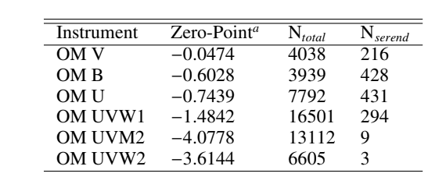

*ESASKy SSOS number of potential XMM-OM serendipitous observations for each colour discriminating broad-band filter[8].*

## 5.3 XMM Newton

The European Space Agency’s (ESA) X-ray Multi-Mirror Mission (XMM-Newton) was launched on December 10th 1990. It constituted ESA’s second cornerstone of the Horizon 2000 Science Programme[9].

At 4 tonnes, and 10 metres, the XMM-Newton spacecraft is the largest scientific satellite ever launched by the European Space Agency. It carries 3 high throughput X-ray telescopes, as well as an optical monitor.

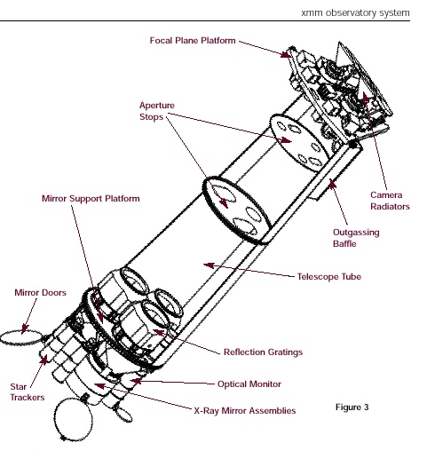

*XMM-Newton spacecraft[10].*

Earth’s atmosphere blocks out all X-rays, thus only a telescope in space can actually detect and observe celestial X-ray sources. As of May 2022, XMM-Newton sits at a tilted (~70 deg inclination) highly eccentric orbit, with a perigee around 26,000 km and an apogee around 100,000 km, resulting in an orbital period of approximately 48 hours[11]. Due to the radiation background from the radiation belts, XMM-Newton’s instruments are limited to altitudes above 46,000 km, i.e. roughly 40 hours of operational time each orbit[12].

XMM-Newton’s mission is aiding the scientific community in solving a number of cosmic mysteries. Scientists can therefore apply for observing time on XMM-Newton, which are granted on a competitive basis.

Even today, more than 20 years after its launch, XMM-Newton keeps providing useful data for the scientific community. As of 2017 the XMM-Newton observatory had already reached 5,000 science papers in the referred literature[13].

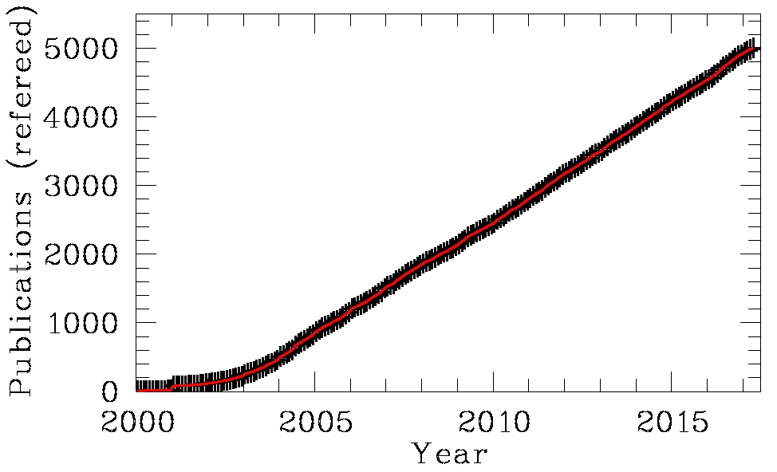

*Number of XMM-Newton publications in refereed journals.*

### 5.3.1 Optical/UV Monitor Telescope

The Optical/UV Monitor Telescope (XMM-OM or OM) provides coverage between 170 nm and 650 nm. It consists of a Telescope Module and a separate Digital Electronics Module. The former contains the optics and detectors, the latter houses the Instrument Control Unit (in charge of communication with the spacecraft and commanding of the instrument) as well as the Data Processing Unit (which carries out the pre-processing of the data before it is sent to the ground)[14].

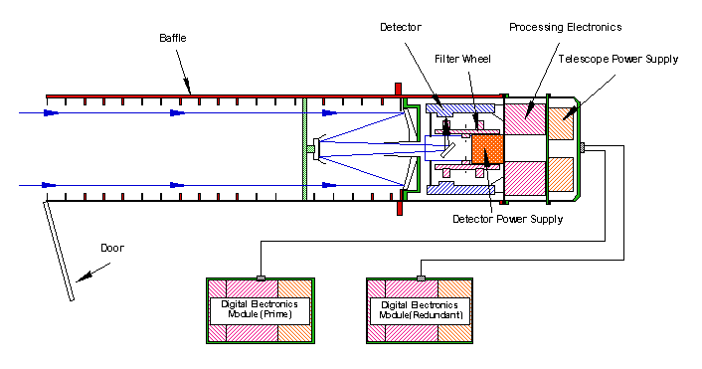

*A schematic of the Optical/UV Monitor Telescope.*

Some of OM’s main characteristics:

* 2m long telescope tube.
* 30cm aperture Ritchey-Chretien telescope.
* f/12.7 focal ratio.
* 3.8m focal length.
* 6 broad band filters.

The 6 broad band filters for colour discrimination in the UV and optical, cover the wavelength range between 180 nm and 580 nm[15]:

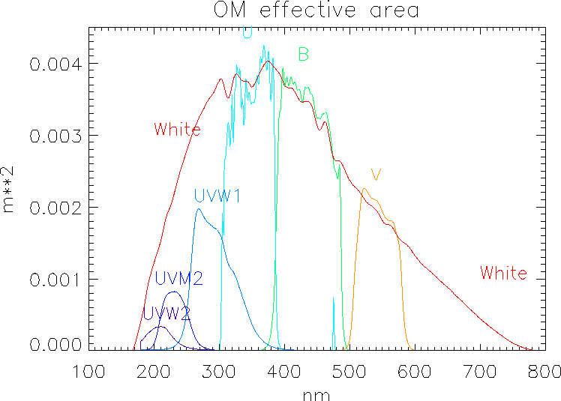

*Throughput curves for the OM filters, folded with the detector sensitivity[16].*

The following table outlines the 6 colour discrimination broad band filters as well as their alternative nomenclature used throughout the present document:

| **Filter** | **Colour discrimination** | **Alternative name** |
| --- | --- | --- |
| UVW2 | UV | S |
| UVM2 | UV | M |
| UVW1 | UV | L |
| U | Optical | U |
| B | Optical | B |
| V | Optical | V |

*XMM-OM colour discrimination filters nomenclature.*

ESA provides the limiting magnitude for a 5-𝜎 detection in 1000 seconds for its U,B,V and UVW1 (L) filters for different star spectral types:

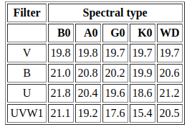

*Limiting magnitude for a 5-𝜎 detection in 1000 seconds[17].*

## 5.4 Objective

As XMM-Newton Optical/UV Monitor Telescope continues gathering information and serving specific observation requests from the scientific community, the chances of it unintentionally observing asteroids (i.e. ‘by chance’) increases. The objective of this Master's Thesis is to leverage previous work in the area to try and obtain Optical/UV colours for some of the asteroids observed serendipitously.

The process to achieve this objective can be outlined as:

1. Selection of candidate observations: during this step, we shortlist the observations provided by ESASky SSOSS that could contain data in line with our objective.
2. Screening: at this point the observations shortlist is shrinked further to exclude any instance with none or insufficient data.
3. Photometry: a calibrated magnitude in both optical and UV is obtained for the observations that passed the screening.

The next chapter (‘Methodology’) details each one of the above-mentioned steps.

# 

# 6 Methodology

This section describes the end-to-end process carried out. It’s presented in a sequential manner:

* Candidate selection: describes which and how the candidate from serendipitous observations were filtered.
* Screening: describes how actual serendipitous observations are set apart from the non-promising candidates.
* Photometry: walks through the photometric process of said serendipitous observations.

## 6.1 Candidates selection

We refer to “candidates” as those observations that could potentially include a non-targeted Solar System Object (SSO) in their field of view (FoV), capturing data in wavelengths that might be of interest. The candidate selection leverages on previous work, the Solar System Object Search Service (SSOSS) catalogue for XMM-Newton OM, which provides up to 985 potential serendipitous detections[18]:

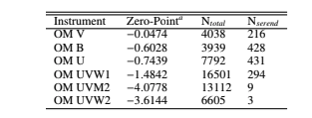

*ESASKy SSOS number of potential XMM-OM serendipitous observations for each colour discriminating broad-band filter.*

These 985 potential detections were filtered out considering:

* Geometrical constraints assessing whether the SSO could have been in the instrument FoV.
* Instrumental constraints assessing whether the SSO apparent magnitude as seen from the instrument would be above its detection threshold.

The list of 985 observations is then trimmed further attending to the wavelengths (i.e. filters) of interest. We will consider observations that fulfil both of the following conditions:

* The observation used one or more of filters S, M and/or L (i.e. UVW2, UVM2 and-or UVW1).
* The observation used one or more of filters U, B and/or V.

After applying the above-mentioned constraints, the list is reduced down to 95 candidate observations (which can be found in the Annexes section). This will constitute the final list of candidates that will be subject to the screening process.

| **N** | **observation** | **sso_name** | **ra1** | **dec1** | **ra2** | **dec2** | **filters** |
| --- | --- | --- | --- | --- | --- | --- | --- |
| 1 | 0012440101 | Lictoria | 13.99603658 | -1.415317889 | 14.07883767 | -1.363111917 | L;B |
| 2 | 0081340801 | Stepanov | 183.3527003 | 2.7053835 | 183.433249 | 2.687358 | L;U;B |
| 3 | 0106660601 | 1994 UF2 | 333.6775958 | -17.72910939 | 333.9756773 | -17.53652372 | L;U |
| 4 | 0110980101 | Lucubratio | 170.061614 | 13.66864472 | 170.2531624 | 13.58085442 | L;B |
| 5 | 0110980601 | 1030 T-1 | 199.8925842 | -14.85586353 | 200.1011217 | -14.91287867 | L;U;B |
| 6 | 0111170101 | Velichko | 98.05291688 | 17.67519933 | 98.37874979 | 17.70504883 | L;V |

*A subset of the final 95 candidate observations. The full table can be found in the Annexes section.*

## 6.2 Screening

This section describes the work and process used to filter out candidates and see if they constitute actual detections. None of the shortlisted 95 are guaranteed to contain serendipitous detections so further analysis is needed.

A Python[19] script was written to help with the screening process by partially automating some of its stages.

## 

*Diagram of the screening process.*

The diagram above outlines the different software *entities* that take part in automating the screening process:

1. A starting list of *Observation Candidates* is made available by an *Observations Repository*.
2. The *Observations Repository* is iterated over, providing *Observation* instances. For each one of this instances:
   1. A XMM-Newton Science Archive Crawler (*XSA Crawler*) obtains the images related to the observation.
   2. The *FITS[20] (Flexible Image Transport System) Interface* displays the downloaded images to the user for them to analyse.
   3. The user’s input is recorded by the *Input Interface* and sent over to the *Output Recorder*, which will update and persist the *Screening Results*.

Each one of the above-mentioned *entities* is abstracted, so that one can plug and play different implementations without breaking the entire process. For instance, the *FITS Interface* might have an implementation using a Python FITS library or it might be opening a process to call an external binary (e.g. DS9[21]).

### 6.2.1 Obtaining the observation data

The XMM-Newton Science Archive (XSA)[22] provides both a web-based user interface[23] as well as an HTTP-based (Hypertext Transfer Protocol) API[24] (Application Programming Interface) to obtain XMM-Newton data. XSA is used as the source to extract the candidate observations.

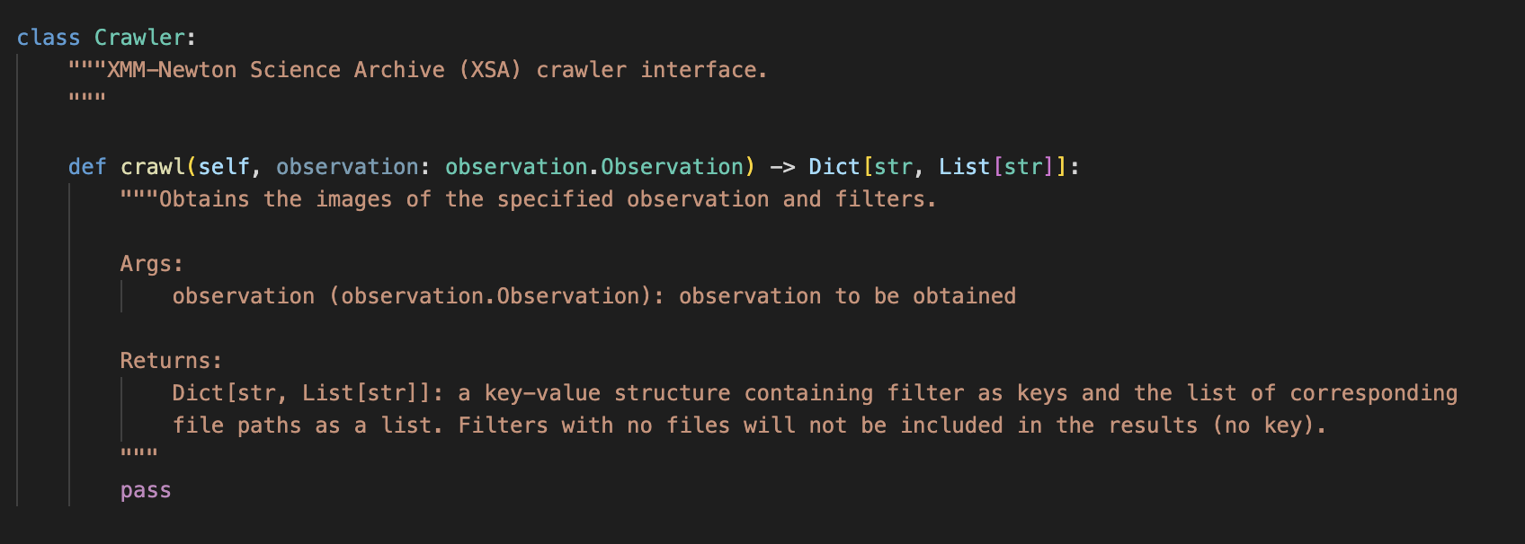

*XMM-Newton Science Archive Crawler.*

An HTTP-based implementation of the *Crawler* interface was used to automate the process of downloading all the relevant data related to a given observation. The data is downloaded locally for it to be displayed and analysed on the next step of the process.

### 6.2.2 Displaying the data

Since the outlined process involves a user-in-the-loop, the data (images) are to be displayed for said user to analyse them.

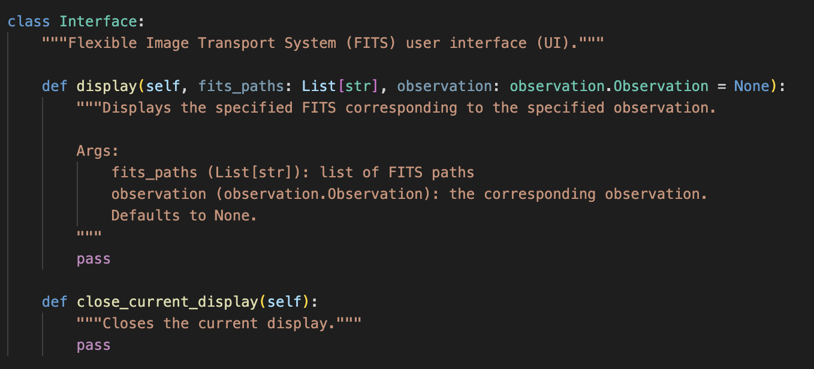

*Flexible Image Transport System (FITS) Interface.*

DS9[25] is an image display and visualisation tool for astronomical data. A DS9-based implementation was used during the screening due to the familiarity with the software and the capabilities it offers.

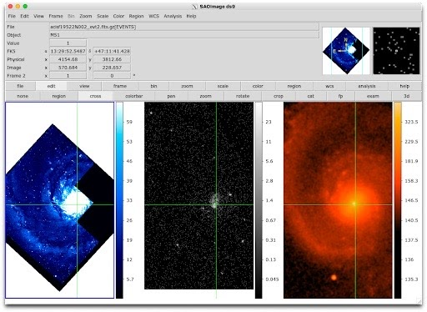

*DS9 user interface.*

DS9 offers command line options[26] to interact with it programmatically. This allowed further automation of the overall screening process, opening DS9 with the relevant set of frames to be analysed with the desired set of parameters.

The one (and so far only) disadvantage of including DS9 as part of the automated screen process is its lack of interactiveness, i.e. once a DS9 instance has been opened via command line, there are no means to interact with it. In order to change any of its current state, (e.g. frames, zoom, etc.) one must close and reopen a new process. This, although saving time overall compared to a manual process, makes the screening a bit slower.

On the other hand, amongst the desired set of parameters above-mentioned, there were some that considerably improved the detection job:

* Trajectory indicators
* Scale adjustment

#### 6.2.2.1 Trajectory indicators

DS9 “Regions” package[27] offers means to overlay shapes on the image. This is used, together with the information from the survey regarding the likely starting and ending position of the object, to display the potential starting and ending point of the object’s trajectory.

The object, if present, is not necessarily likely to be found within the starting or ending area, but somewhere along the line that joins the. This greatly helps the user focus on the likely path of the object rather than on the entire field of view.

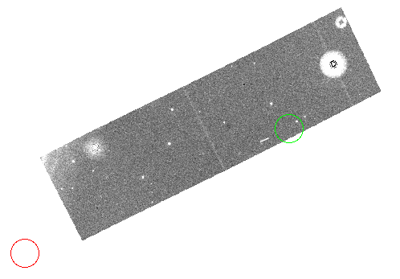

*Trajectory indicators: start (green) and end (red).*

The start and end trajectory indicators are built from the ESASky SSOSS catalogue of potential serendipitous observations.

#### 6.2.2.2 Adjusting DS9 scale

DS9 provides means to modify its default display settings by means of its “scale” menu[28]. As per recommendation from the Thesis Director, the “zscale” command is used as it provides very good contrast to ease the object’s detection.

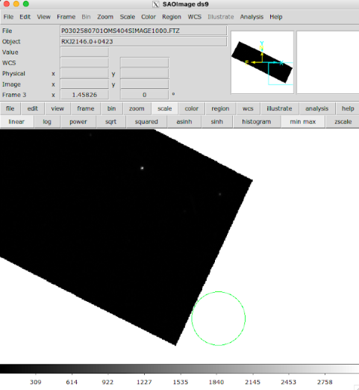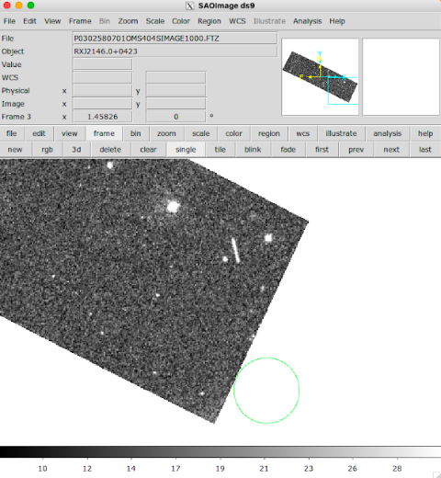

*DS9 linear scale (left) vs zscale (right).*

### 6.2.3 Recording the analysis outcome

Once the user has analysed the data, the software collects their input.

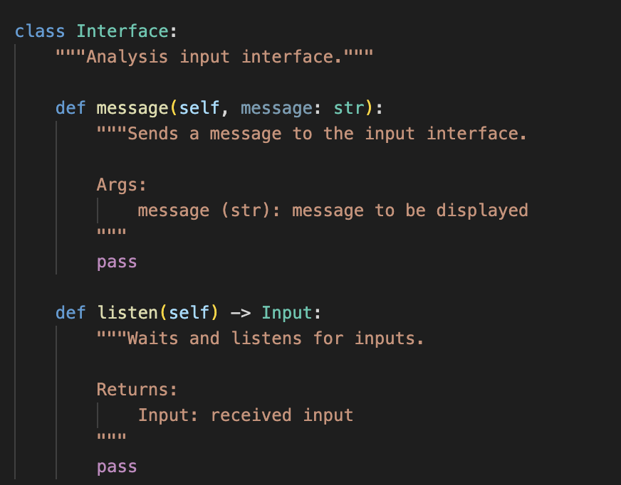

*User input interface.*

A standard input/output (I/O) implementation is used to gather the user’s input. Said input is mostly limited to a shortlist of options:

| * *DETECTED (Y)* | Indicating that the object is distinctively observable in the image. |
| --- | --- |
| * *DUBIOUS (D)* | Used for objects whose presence is not clearly identifiable nor outruled. |
| * *NOT_DETECTED (N)* | Indicating that there is no indication of the object being present in the image. |

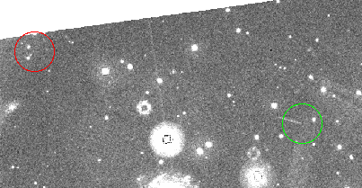

*An example of a clear detection (observation 0692330401 - Ivanka - L filter).*

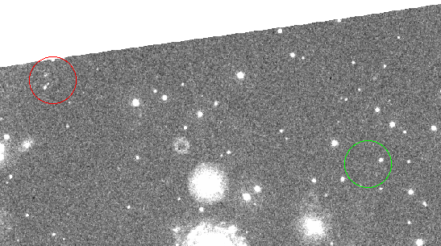

*An example of a “dubious” detection (observation 0692330401 - Ivanka - U filter).*

After each observation, the analysis outcome is recorded.

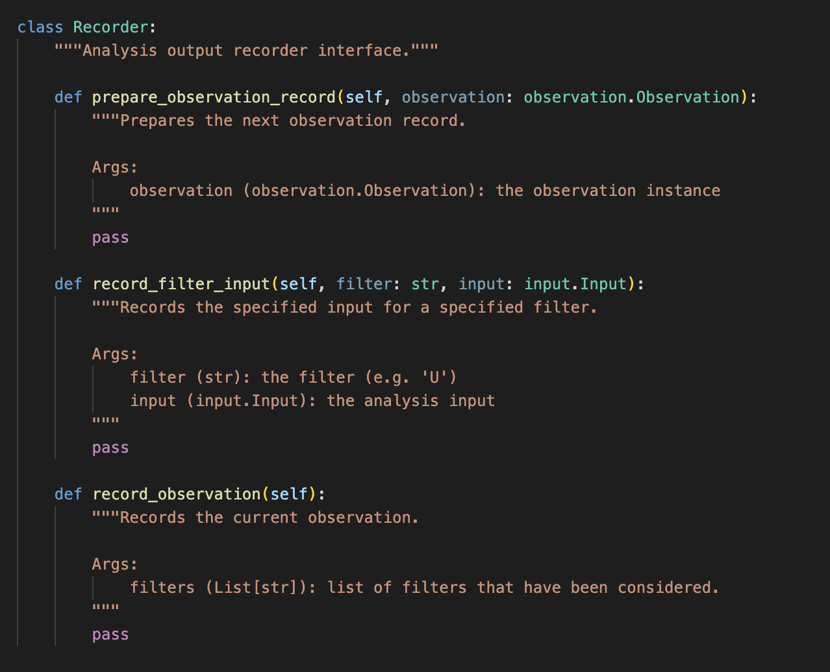

*Analysis output recorder.*

An implementation writing the analysis output to a comma-separated value file (CSV) was used.

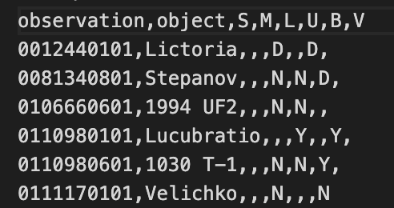

*Sample of the CSV output file recorded during the process.*

The output file can be imported as a table into other analysis tools. Below, the same output, in a table format:

| **N** | **observation** | **object** |  | **S** | **M** | **L** |  | **U** | **B** | **V** |
| --- | --- | --- | --- | --- | --- | --- | --- | --- | --- | --- |
| 1 | 12440101 | Lictoria |  |  |  | D |  |  | D |  |
| 2 | 81340801 | Stepanov |  |  |  | N |  | N | D |  |
| 3 | 106660601 | 1994 UF2 |  |  |  | N |  | N |  |  |
| 4 | 110980101 | Lucubratio |  |  |  | Y |  |  | Y |  |
| 5 | 110980601 | 1030 T-1 |  |  |  | N |  | N | Y |  |
| 6 | 111170101 | Velichko |  |  |  | N |  |  |  | N |

*A subset of the screening results. The full table can be found in the Annexes section.*

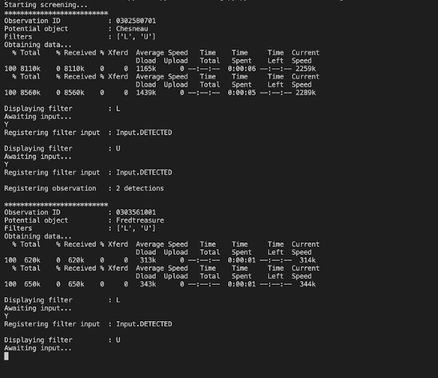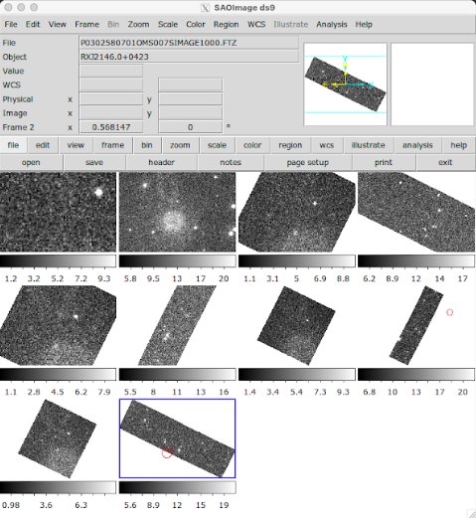

*Screenshots of what the screening process looks like for the user.*

## 6.3 Photometry

This section describes the work and process used to determine the magnitude(s) of the selected objects from the previously described screening process. A piece of Python code, leveraging the popular astronomy library Astropy[29], is written to carry out the following flow:

## 

*Diagram of the photometric process.*

1. The process starts specifying the location of the observation FITS file, which is injected into an *HDU[30] [31] (Header Data Unit) Wrapper* instance.
2. A *PhotTable Wrapper* instance (an Astropy’s *QTable[32]* utility wrapper) is created and fed with said *HDU Wrapper*. One can then:
   1. Download the corresponding “source list” (details of this specific product can be found in the following sections) FITS file from XMM-Newton Science Archive and
   2. obtain the coefficients of the linear model to be used to calibrate the actual observation file.
3. A *User Interface* instance is created and launched, allowing the user to select the trail in the image. The user’s input selection is translated into the two *Rectangular Aperture* instances.
4. The calibrated linear model of the *PhotTable Wrapper* is used together with the *Rectangular Apertures* to calculate the calibrated magnitude of the object.

### 6.3.1 Rectangular aperture (trail) photometry

Aperture photometry is the process by which the light that falls inside a particular aperture is measured. The count rate of the object to be measured is obtained using an aperture containing the object and an annular aperture to measure the surrounding background count-rate. The surrounding background count-rate is subtracted from the first aperture count-rate to determine the actual light coming from the object of interest. Typically, this process is carried out using circular apertures.

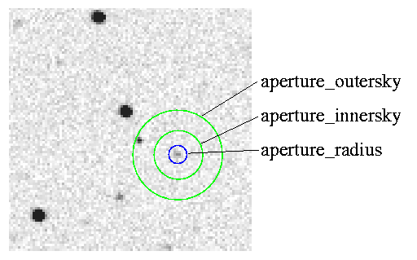

*Circular aperture photometry[33].*

Given the nature of the object trail, rectangular aperture photometry was used instead, where a rectangle and an annular rectangle are used:



*Rectangular aperture photometry.*

Just like in standard circular photometry, where two concentric circles are used, the outer rectangle is used to subtract the background *noise*. In order to determine said rectangles, the user is presented with the observation image for them to select the edges of the trail. The two rectangles are then defined around the selected points with a width that can be programmatically defined.

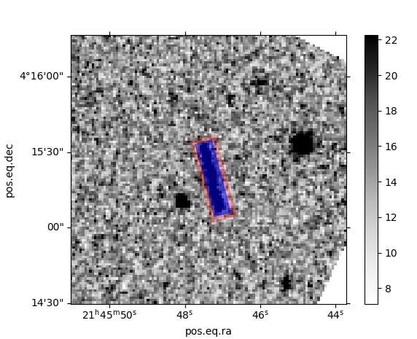

*User interface to define rectangular aperture and annulus.*

The instrumental (measured) magnitude of the object:

Where is the count rate of the objet:

Where:

* is the count of the object aperture
* is the average count of the annular aperture (background count)
* is the exposure time of the image

The Photutils package[34] was used to provide the different functionalities to compute the count of both the object aperture as well as the annular aperture. It was used in conjunction with the Matplotlib[35] to produce the user interface for aperture selection and magnitude computation.

### 6.3.2 Magnitude calibration

The aforementioned steps provide the instrumental magnitude of the object. This section describes how said magnitude is calibrated against a photometric system.

ESA has published several methods for XMM-Newton OM magnitude calibration and count rate to flux conversions[36]. Given its simplicity, method 3 “AB MAGNITUDE SYSTEM” was used. An AB magnitude system is a photometric system defined so that the zero-point flux for each filter is [37].

The zero-point values for each filter are published by ESA[38] but can be also programmatically obtained from the “source list” files (*SRCLIST* in XMM-Newton terminology). The header of this file contains the “zero-points and conversion factors[39].

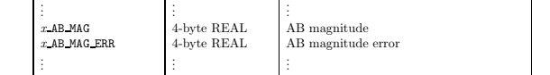

*Subset of SRCLIST headers containing conversion factors.*

These parameters are then leveraged to perform calibration of the object’s computed aperture photometry using the following expression:

Where:

## 

# 7 Results & analysis

This section breaks down in deeper detail the results obtained from each one of the steps described in the methodology section. It also includes a section outlining potential future work and improvements.

## 7.1 Screening

After completing the screening of all **95** candidate observations…

* …there are **30** observations where the object might have been detected (i.e. “dubious” or “clear” detection) in one or more of either the {S,M,L} filters or the {U,B,V} filters (i.e. not UV/optical overlap)...
* …out of which there are **9** observations where the object might have been detected (i.e. “dubious” or “clear” detection) in one or more of the {S,M,L} filters as well as in one or more of the {U,B,V} filters…
* …out of which there are **3** observations the object has been detected (i.e. “clear” detection) in one or more of the {S,M,L} filters as well as in one or more of the {U,B,V} filters.

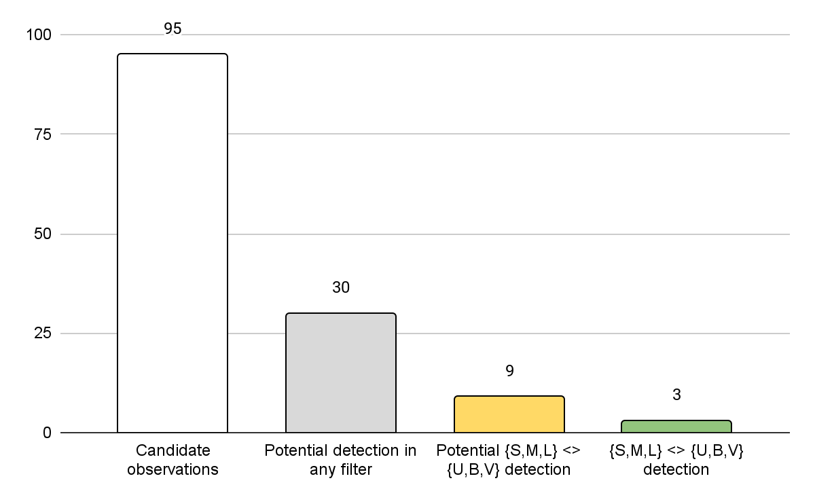

*Observations breakdown after the screening process.*

The 3 observations where the object has been detected in both one or more {S,M,L} filters and one or more {U,B,V} filters are:

| **N** | **observation** | **object** |  | **S** | **M** | **L** |  | **U** | **B** | **V** |
| --- | --- | --- | --- | --- | --- | --- | --- | --- | --- | --- |
| 4 | 110980101 | Lucubratio |  |  |  | **X** |  |  | **X** |  |
| 25 | 302580701 | Chesneau |  |  |  | **X** |  | **X** |  |  |
| 26 | 303561001 | Fredtreasure |  |  |  | **X** |  | **X** |  |  |

*Observations showing one or more clear detections in both {S,M,L} and {U,B,V} filters.*

The actual images of the 3 above-mentioned objects can be found in the Annexes section.

## 

## 7.2 Photometry

The 3 observations where detections in both UV {S,M,L} and optical {U,B,V} filters exist are photometrically analysed using the process described in the Methodology section. A series of captures and tables showcasing the photometric process and parameters are presented below for each one of the images for all 3 observations:



Where:

* is the width of the rectangular aperture in pixels.
* is the half-width of the annular aperture in pixels.

### 7.2.1 Obs. 110980101 - Lucubratio

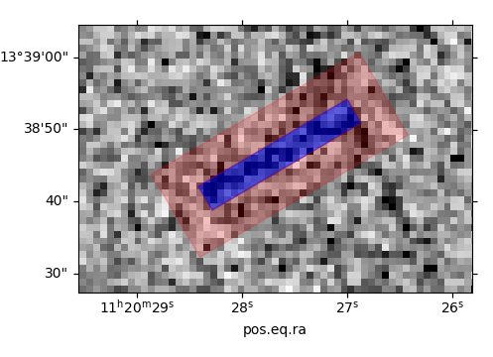

| Image | Filter |  |  |  |
| --- | --- | --- | --- | --- |
| P0110980101OMS406SIMAGE1000 | L | 4 | 5 | **20.82** |

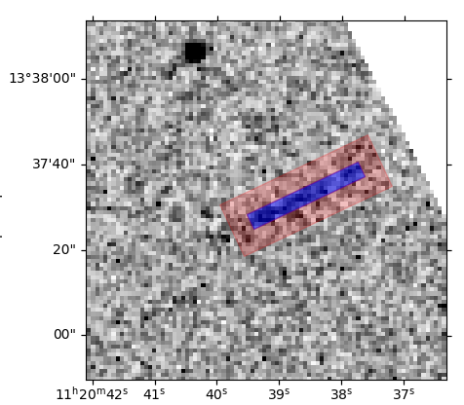

| Image | Filter |  |  |  |
| --- | --- | --- | --- | --- |
| P0110980101OMS411SIMAGE1000 | L | 4 | 5 | **20.70** |

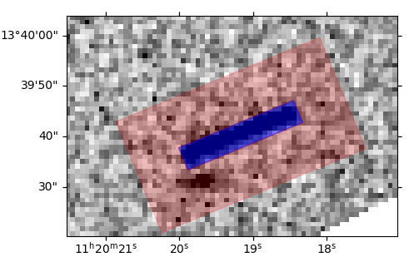

| Image | Filter |  |  |  |
| --- | --- | --- | --- | --- |
| P0110980101OMS402SIMAGE1000 | B | 5 | 10 | **18.25** |

### 7.2.2 Obs. 0302580701 - Chesneau

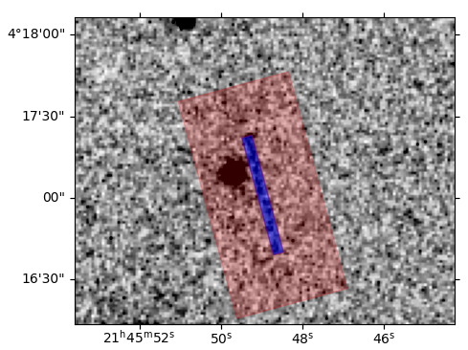

| Image | Filter |  |  |  |
| --- | --- | --- | --- | --- |
| P0302580701OMS405SIMAGE1000 | L | 4 | 20 | **20.57** |

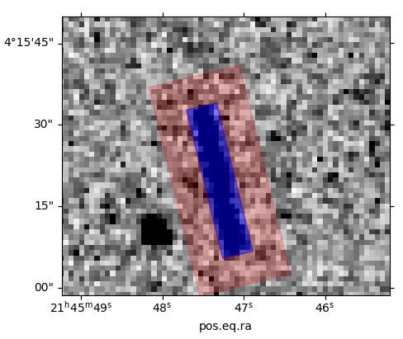

| Image | Filter |  |  |  |
| --- | --- | --- | --- | --- |
| P0302580701OMS404SIMAGE1000 | U | 6 | 6 | **18.82** |

### 7.2.3 Obs. 0303561001 - Fredtreasure

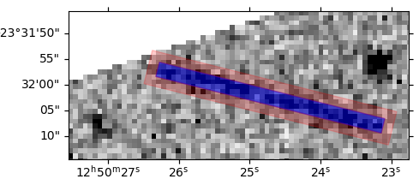

| Image | Filter |  |  |  |
| --- | --- | --- | --- | --- |
| P0303561001OMS007SIMAGE0000 | L | 3 | 2 | **20.40** |

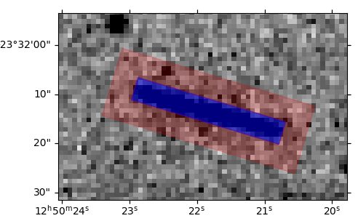

| Image | Filter |  |  |  |
| --- | --- | --- | --- | --- |
| P0303561001OMS006SIMAGE0000 | U | 3 | 2 | **18.93** |

### 7.2.4 Magnitudes and colours

The following table summarises the magnitudes and UV-Optical colours in the AB system (the average figure has been provided if there were 2 or more measurements):

|  |  | **UV Magnitude(s)** | | |  | **Optical Magnitude(s)** | | |  | **Colours** | |
| --- | --- | --- | --- | --- | --- | --- | --- | --- | --- | --- | --- |
| **Object** |  | **S** | **M** | **L** |  | **U** | **B** | **V** |  | **L-U** | **L-B** |
| Lucubratio |  |  |  | 20.76 |  |  | 18.25 |  |  |  | 2.51 |
| Chesneau |  |  |  | 20.57 |  | 18.82 |  |  |  | 1.75 |  |
| Fredtreasure |  |  |  | 20.40 |  | 18.93 |  |  |  | 1.47 |  |

*Computed magnitudes and colours for the 3 observations showing one or more clear detections in both {S,M,L} and {U,B,V} filters.*

## 

## 7.3 Future work and improvements

Several improvements and potential future lines of work are discussed below:

* **Image-trajectory overlap**: currently all images of a possible observation are displayed during the screening process. In the *best* case scenario, there is only one, while in the *worst* case scenario there might be up to 30 images. Many of these images footprint do not overlap with the actual trajectory of the object, thus displaying many images for analysis where the chance of detecting the object is virtually impossible. This is quickly ruled out by the user thanks to the trajectory indicators, but one could optimise the process further by ruling them out programmatically before even presenting them for screening.
* Full **automation**: at the moment, the figure of a user is necessary (“human in the loop”), however, one could include a trail detection algorithm and fully automate both the screening and the photometric process.
* Re-running against an **updated catalogue** version: the present work is based on the ESASky SSOSS catalogue published towards the end of 2021, where all the starting 985 potential observations were made available. One could re-run the whole cross-matching process and provide another list of observations to analyse.
* Remove **DS9 dependency**: whilst DS9 is a powerful tool, it currently offers a few limitations when it comes to its programmatic usage. One could utilise a Python library for the display of FITS files. The current software pattern would allow for the implementation and easy “plug-in” of a Python-based FITS interface.

# 8 Bibliography

(n.d.). SAOImageDS9. https://sites.google.com/cfa.harvard.edu/saoimageds9

(n.d.). Command Line Options. http://ds9.si.edu/doc/ref/command.html

(n.d.). Regions. http://ds9.si.edu/doc/ref/region.html

(n.d.). DS9 Scale Menu. http://spiff.rit.edu/tass/ds9/mscale.html

(n.d.). Welcome to Python.org. https://www.python.org/

(n.d.). Astropy. https://www.astropy.org/

(n.d.). Simple Aperture Photometry by Hand. http://spiff.rit.edu/classes/phys445/lectures/photom/photom.html

(n.d.). Photutils — photutils 1.7.0. https://photutils.readthedocs.io/en/stable/

(n.d.). Matplotlib — Visualization with Python. https://matplotlib.org/

(n.d.). 16. Magnitude Systems. http://faraday.uwyo.edu/~admyers/ASTR5160/handouts/516016.pdf

(2021, January 17). FITS Support Office. https://fits.gsfc.nasa.gov/fits_home.html

*Bands - XMM-Newton - Cosmos*. (n.d.). cosmos esa. https://www.cosmos.esa.int/web/xmm-newton/om-filter-bands

Brune, W. H. (n.d.). *6.4 The Solar Spectrum | METEO 300: Fundamentals of Atmospheric Science*. Dutton Institute. https://www.e-education.psu.edu/meteo300/node/683

*ESA Science & Technology - Orbit/Navigation*. (n.d.). ESA Science & Technology. https://sci.esa.int/web/xmm-newton/-/31349-orbit-navigation

*Filter Wheel - XMM-Newton - Cosmos*. (n.d.). cosmos.esa.int. https://www.cosmos.esa.int/web/xmm-newton/om-filter

*FITS Primer*. (2014, October 28). NASA FITS. https://fits.gsfc.nasa.gov/fits_primer.html

*5000 Papers - XMM-Newton*. (n.d.). cosmos.esa.int. https://www.cosmos.esa.int/web/xmm-newton/5000-papers

*4.1 XMM-Newton orbit*. (n.d.). European Space Agency. https://xmm-tools.cosmos.esa.int/external/xmm_user_support/documentation/uhb/orbit.html

*Header Data Unit — Astropy v5.2.1*. (n.d.). Astropy. https://docs.astropy.org/en/stable/io/fits/api/hdus.html

*QTable — Astropy v5.2.1*. (n.d.). Astropy. https://docs.astropy.org/en/stable/api/astropy.table.QTable.html#astropy.table.QTable

Racero, E. (2022). ESASky SSOSS: Solar System Object Search Service and the case of Psyche. *Astronomy & Astrophysics*, *659*, A38.

Rodríguez, P. (n.d.). XMM-Newton Science Archive. http://nxsa.esac.esa.int/nxsa-web/#search

Rodríguez, P. (n.d.). XMM-Newton Science Archive. http://nxsa.esac.esa.int/nxsa-web/#aio

*SAS Watchout - uvflux - XMM-Newton - Cosmos*. (n.d.). Cosmos.esa.int. https://www.cosmos.esa.int/web/xmm-newton/sas-watchout-uvflux

*The Science Programme*. (n.d.). European Space Agency. https://www.esa.int/esapub/br/br114/br114sci.htm

*Technical Details - OM - XMM-Newton - Cosmos*. (n.d.). cosmos.esa.int. https://www.cosmos.esa.int/web/xmm-newton/technical-details-om

*Technical Details - Spacecraft - XMM-Newton - Cosmos*. (n.d.). cosmos.esa.int. https://www.cosmos.esa.int/web/xmm-newton/technical-details-spacecraft

*3.5.5 OM sensitivity and detection limits*. (n.d.). European Space Agency. https://xmm-tools.cosmos.esa.int/external/xmm_user_support/documentation/uhb/omlimits.html

Waszczak, A. (2015, 05 06). Asteroids in GALEX: Near-ultraviolet photometry of the major taxonomic groups.

*XMM-Newton Science Archive - XMM-Newton*. (n.d.). cosmos esa. https://www.cosmos.esa.int/web/xmm-newton/xsa

XMM-Newton Specifications for Individual SSC Data Products & Science Survey Center Teams. (2021, 04 12). XMM-Newton Calibration Access and Data Handbook. (4.6), 29-30.

# 9 Annexes

## 9.1 Candidate observations

The following table outlines all 95 potential XMM-Newton serendipitous observations of interest, where:

* is the row ordinal.
* is the observation ID (as per XMM-Newton’s Science Archive).
* is the potential Solar System Object name in the XMM-Newton OM FoV.
* is the SSO’s right ascension and declination at the start of the observation.
* is the SSO’s right ascension and declination at the end of the observation.
* indicates the potential filters used during the observation.

| **N** | **observation** | **sso_name** | **ra1** | **dec1** | **ra2** | **dec2** | **filters** |
| --- | --- | --- | --- | --- | --- | --- | --- |
| 1 | 0012440101 | Lictoria | 13.99603658 | -1.415317889 | 14.07883767 | -1.363111917 | L;B |
| 2 | 0081340801 | Stepanov | 183.3527003 | 2.7053835 | 183.433249 | 2.687358 | L;U;B |
| 3 | 0106660601 | 1994 UF2 | 333.6775958 | -17.72910939 | 333.9756773 | -17.53652372 | L;U |
| 4 | 0110980101 | Lucubratio | 170.061614 | 13.66864472 | 170.2531624 | 13.58085442 | L;B |
| 5 | 0110980601 | 1030 T-1 | 199.8925842 | -14.85586353 | 200.1011217 | -14.91287867 | L;U;B |
| 6 | 0111170101 | Velichko | 98.05291688 | 17.67519933 | 98.37874979 | 17.70504883 | L;V |
| 7 | 0137550501 | Vermeer | 83.65883033 | 21.96132228 | 83.72975342 | 21.95673122 | L;U |
| 8 | 0148090501 | 2000 VH57 | 268.6228585 | -26.34105697 | 268.6597257 | -26.33875756 | L;B |
| 9 | 0148560501 | 2000 OR6 | 157.6945887 | 5.506792639 | 157.9910666 | 5.444162528 | L;V |
| 10 | 0153450101 | Coubertin | 191.7900402 | -5.714503389 | 192.0338537 | -5.8043765 | L;B |
| 11 | 0153950901 | 2000 SG172 | 245.6509016 | -15.71548278 | 245.687865 | -15.72228931 | L;U |
| 12 | 0164570401 | 1998 QN30 | 229.0141158 | -16.05640242 | 229.2929736 | -16.14343586 | L;U |
| 13 | 0202680101 | 1992 AJ1 | 263.4018785 | -26.09088186 | 263.940696 | -26.11426953 | L;U |
| 14 | 0202680101 | Puntel | 263.1458409 | -26.11714492 | 263.7103745 | -26.16403192 | L;U |
| 15 | 0202730101 | Kiyosato | 155.414775 | 21.64732233 | 155.5115943 | 21.58226161 | L;U;B |
| 16 | 0203170301 | 1998 YB12 | 187.924908 | 0.3078198611 | 188.2312754 | 0.1890703333 | L;U;B;V |
| 17 | 0203450201 | 1941 UN | 330.777767 | -19.12108378 | 330.9844593 | -19.069593 | L;U |
| 18 | 0203850201 | 1981 ET34 | 278.7704483 | -7.654013611 | 278.8745769 | -7.677327028 | L;U |
| 19 | 0206060101 | 1993 UB3 | 358.6213643 | 5.807185972 | 358.7399671 | 5.873919833 | L;U |
| 20 | 0206060201 | Vanavara | 144.8699843 | 14.97476194 | 144.9659829 | 14.94839681 | L;U |
| 21 | 0206490301 | Africa | 337.1189521 | -24.69079364 | 337.2161115 | -24.68050169 | L;U |
| 22 | 0300240101 | Mucha | 139.650819 | 16.33086269 | 139.7237488 | 16.31634964 | L;U;B |
| 23 | 0300480301 | 1994 YO1 | 133.5344843 | 20.16909269 | 133.6593827 | 20.11736764 | L;U;B;V |
| 24 | 0300960631 | Hermitage | 204.3960185 | -9.539437083 | 204.4068013 | -9.540443056 | L;B |
| 25 | 0302580701 | Chesneau | 326.4374095 | 4.212535 | 326.5023323 | 4.446862 | L;U |
| 26 | 0303561001 | Fredtreasure | 192.5847993 | -23.53889469 | 192.6238483 | -23.529534 | L;U |
| 27 | 0312790101 | 1999 AD32 | 83.45220263 | 21.92756267 | 83.58099579 | 21.99086489 | L;U |
| 28 | 0402360101 | 2006 BQ6 | 27.57513963 | 32.19779597 | 20.13579171 | 33.51657169 | M;L;U;B |
| 29 | 0402430301 | Masciarelli | 266.332632 | -28.93590631 | 266.5198225 | -28.98743756 | L;U |
| 30 | 0402750301 | Kazo | 35.18939329 | 19.84358708 | 35.31994388 | 19.90695697 | L;U |
| 31 | 0500760101 | 1999 XN105 | 168.2132115 | 13.48386681 | 168.2961424 | 13.48310722 | L;U |
| 32 | 0501270301 | The | 98.40760025 | 17.72570306 | 98.44330771 | 17.72696461 | L;U |
| 33 | 0502091601 | Kulibin | 139.6860336 | 16.17447492 | 139.9306879 | 16.10896939 | L;B |
| 34 | 0502120101 | Ibuki | 184.5898656 | 5.767884056 | 185.0411175 | 5.664890611 | L;U;V |
| 35 | 0502430101 | 2000 BJ4 | 197.675828 | -5.848601611 | 197.8108237 | -5.93855275 | L;U |
| 36 | 0503490201 | Naruke | 340.5789013 | -9.697185722 | 340.805813 | -9.601553056 | L;U |
| 37 | 0503490201 | 2000 QP27 | 340.263912 | -9.828102417 | 340.9032975 | -9.58547225 | L;U |
| 38 | 0504780501 | 1999 XQ57 | 193.2852633 | -9.254789083 | 193.5174435 | -9.269204778 | L;U |
| 39 | 0552860101 | Nantong | 163.640493 | -5.670915611 | 163.651515 | -5.753722778 | L;U |
| 40 | 0556212301 | Amenemhet | 223.6749917 | 1.731918444 | 223.7060366 | 1.711334833 | M;L;B |
| 41 | 0601391001 | Joan | 311.1092784 | -10.79975797 | 311.3062858 | -10.78449478 | S;M;L;U;B;V |
| 42 | 0601670101 | 1986 RP5 | 19.7594455 | 3.550315778 | 19.94961175 | 3.669347333 | M;L;U |
| 43 | 0604740101 | Lijiang | 321.4909871 | -12.20326347 | 321.776253 | -12.12629567 | M;L;U |
| 44 | 0604740101 | 2000 NA6 | 321.2284947 | -12.19873319 | 321.6523976 | -12.00705717 | M;L;U |
| 45 | 0650510301 | 1999 SG12 | 23.21132146 | 30.93349644 | 23.55411408 | 31.11216489 | M;L;U;B |
| 46 | 0653840401 | Grotius | 24.86671587 | 6.247936944 | 24.93093133 | 6.264996833 | S;M;L;U |
| 47 | 0653950201 | 1993 SG1 | 82.50929946 | 10.55111419 | 82.71532771 | 10.47722242 | L;U;B;V |
| 48 | 0656200101 | 2000 WU93 | 137.2766764 | 14.62784539 | 137.3296748 | 14.61574197 | M;L;U |
| 49 | 0670120301 | Chrisclark | 343.5239665 | -17.82484172 | 343.5560615 | -17.647393 | S;M;L;U;B;V |
| 50 | 0670880401 | 1999 AN25 | 343.271595 | 11.46389467 | 343.5867534 | 11.57390897 | S;M;L;U |
| 51 | 0672990201 | 1994 CG2 | 318.0854782 | -30.82999664 | 318.248346 | -30.79596678 | M;L;U |
| 52 | 0673310101 | 2000 JZ79 | 186.3821592 | 13.11793753 | 186.443617 | 12.82925503 | M;L;U |
| 53 | 0673310101 | 2000 AV91 | 186.1031917 | 13.03456053 | 186.2139895 | 12.89814914 | M;L;U |
| 54 | 0673550201 | 1996 YP | 265.897439 | -29.70555036 | 266.1531568 | -29.73510025 | M;L;U |
| 55 | 0674370201 | Zurich | 136.799451 | 14.87054631 | 137.150276 | 14.6254395 | M;L;U |
| 56 | 0674480401 | Potomac | 211.0622944 | -1.794742861 | 211.0822733 | -1.792068667 | L;U |
| 57 | 0692330401 | Ivanka | 112.1893285 | 33.89455739 | 112.3496495 | 33.93021694 | M;L;U |
| 58 | 0692330501 | 1998 HF34 | 171.3479332 | 14.55508569 | 171.4278274 | 14.53439111 | M;L;U |
| 59 | 0692510201 | Quaide | 142.1817295 | 18.83117456 | 142.2683561 | 18.82097528 | M;L;V |
| 60 | 0693820201 | 2000 RX67 | 197.619011 | -1.358278028 | 197.819275 | -1.411782806 | M;L;U |
| 61 | 0694510101 | Siegena | 212.153216 | -3.086574139 | 212.3203522 | -3.078343194 | M;L;U;B |
| 62 | 0700182001 | Landi | 322.2720505 | -7.793742944 | 322.3753971 | -7.771863972 | M;L;U |
| 63 | 0721010501 | 1989 ST10 | 262.0557056 | -14.185319 | 262.5758778 | -14.32163672 | S;M;L;U;B;V |
| 64 | 0722310201 | Auster | 311.8667542 | -10.03062875 | 312.1446029 | -9.988439417 | M;L;U |
| 65 | 0723800701 | 1981 FT | 181.0776443 | 1.763994861 | 181.4599945 | 1.556985611 | S;M;L;U;B;V |
| 66 | 0727771001 | 1988 XT1 | 329.8151669 | -30.24738586 | 329.9649954 | -30.22888356 | S;M;L;B |
| 67 | 0740920301 | Tampere | 189.9916692 | -5.242599694 | 190.0440417 | -5.266937222 | S;L;U |
| 68 | 0742570101 | 1990 QT9 | 130.4161485 | 19.43254819 | 130.512747 | 19.40390586 | M;L;U |
| 69 | 0743050301 | 2000 SL1 | 13.22112492 | 12.73247244 | 14.08068717 | 12.77018519 | S;M;L;U;B;V |
| 70 | 0743630501 | 2000 SG234 | 266.160831 | -28.99608153 | 266.4460373 | -29.01865606 | M;L;U |
| 71 | 0743950501 | Aakashshah | 146.3334294 | 10.01490692 | 146.5087875 | 9.944300806 | S;M;L;B;V |
| 72 | 0744420101 | 1988 RK | 276.5005378 | -12.98744389 | 277.1083537 | -13.11541775 | S;M;L;B |
| 73 | 0744440301 | Lipschutz | 191.5872185 | 2.524155889 | 192.0992658 | 2.315665 | S;M;L;U;V |
| 74 | 0744440301 | 2001 FV5 | 191.3991292 | 2.555875667 | 191.8783471 | 2.321374083 | S;M;L;U;V |
| 75 | 0748190101 | 1999 WA3 | 28.89897346 | 5.562144528 | 29.00509067 | 5.689929778 | M;L;U;B;V |
| 76 | 0748391301 | 1998 EC9 | 266.4610222 | -20.21344439 | 267.1787076 | -20.26542956 | S;M;L;U |
| 77 | 0762520301 | Boyan | 135.95937 | 15.10115797 | 136.1865554 | 15.03699531 | S;M;L;U;B;V |
| 78 | 0763100101 | Raissa | 272.4010435 | -26.10797106 | 272.7722155 | -26.09434092 | S;M;L;U |
| 79 | 0763100101 | Silentium | 272.7717822 | -26.24762669 | 273.2145032 | -26.20041814 | S;M;L;U |
| 80 | 0782650101 | 1999 RU128 | 148.4771184 | 1.610909611 | 148.5702264 | 1.573129028 | M;L;U |
| 81 | 0793183501 | Pluto | 290.4538513 | -21.19250028 | 290.4627145 | -21.19216222 | L;U;B;V |
| 82 | 0793183801 | Pluto | 290.5976094 | -21.20850228 | 290.5941724 | -21.21058642 | L;U;B;V |
| 83 | 0800380101 | Aimeemcarthy | 334.2823285 | -3.633520861 | 334.5500116 | -3.628896917 | M;L;U |
| 84 | 0800400501 | Sarpedon | 137.5143637 | -0.7671195 | 137.5362295 | -0.744149 | M;L;U |
| 85 | 0800400601 | 2002 VU94 | 132.693046 | -0.0530325 | 132.6390517 | 0.05990219444 | M;L;U |
| 86 | 0803161101 | Asteropaios | 159.304195 | -2.555804833 | 159.3039392 | -2.567429139 | L;B |
| 87 | 0803950801 | Salazar | 146.9090978 | 14.37213733 | 146.9327653 | 14.36387231 | L;B |
| 88 | 0803952201 | Reseda | 180.29188 | 1.151024972 | 180.3209618 | 1.136621639 | L;B |
| 89 | 0803952601 | Joensuu | 126.3411467 | 31.90827689 | 126.4194533 | 31.91556219 | L;B |
| 90 | 0804250301 | Flagstaff | 266.6556002 | -29.83210128 | 266.7527539 | -29.84931656 | S;M;L;U;B |
| 91 | 0810600201 | 2001 UY127 | 50.2470725 | -1.158312056 | 50.30279604 | -1.026853944 | M;L;U |
| 92 | 0811212701 | 1999 XT90 | 197.299954 | -23.56913144 | 197.4071665 | -23.70903806 | M;L;U |
| 93 | 0820460101 | 1999 FC32 | 177.9620883 | 3.972947472 | 178.0113729 | 3.942962222 | L;V |
| 94 | 0821250601 | 2000 VR36 | 35.83477292 | -3.512480722 | 36.04166496 | -3.298254861 | M;L;U |
| 95 | 0830191001 | 2001 AG18 | 197.108645 | -23.29220028 | 197.2994372 | -23.30699 | M;L;U |

## 

## 

## 9.2 Screening results

The following table contains the screening results for all 95 potential XMM-Newton serendipitous observations of interest, where:

* is the row ordinal.
* is the observation ID (as per XMM-Newton’s Science Archive).
* is the potential Solar System Object name in the XMM-Newton OM FoV.
* is the screening result for a particular filter, where:
  + indicates a clear detection.
  + indicates a dubious detection.
  + indicates no detection.

Rows have been colour-coded, where:

|  | The object has not been detected. |
| --- | --- |
|  | The object might have been detected in one or more filters but either in the {S,M,L} filters or in the {U,B,V} filters. |
|  | The object might have been detected (i.e. “dubious” or “clear” detection) in one or more of the {S,M,L} filters as well as in one or more of the {U,B,V} filters. |
|  | The object has been detected (i.e. “clear” detection) in one of the {S,M,L} filters as well as in one of the {U,B,V} filters. |

| **N** | **observation** | **object** |  | **S** | **M** | **L** |  | **U** | **B** | **V** |
| --- | --- | --- | --- | --- | --- | --- | --- | --- | --- | --- |
| 1 | 12440101 | Lictoria |  |  |  | D |  |  | D |  |
| 2 | 81340801 | Stepanov |  |  |  | N |  | N | D |  |
| 3 | 106660601 | 1994 UF2 |  |  |  | N |  | N |  |  |
| 4 | 110980101 | Lucubratio |  |  |  | Y |  |  | Y |  |
| 5 | 110980601 | 1030 T-1 |  |  |  | N |  | N | Y |  |
| 6 | 111170101 | Velichko |  |  |  | N |  |  |  | N |
| 7 | 137550501 | Vermeer |  |  |  | N |  | N |  |  |
| 8 | 148090501 | 2000 VH57 |  |  |  | N |  |  | Y |  |
| 9 | 148560501 | 2000 OR6 |  |  |  | N |  |  |  | N |
| 10 | 153450101 | Coubertin |  |  |  | N |  |  | N |  |
| 11 | 153950901 | 2000 SG172 |  |  |  | N |  | Y |  |  |
| 12 | 164570401 | 1998 QN30 |  |  |  | N |  | N |  |  |
| 13 | 202680101 | 1992 AJ1 |  |  |  | N |  | N |  |  |
| 14 | 202680101 | Puntel |  |  |  | N |  | N |  |  |
| 15 | 202730101 | Kiyosato |  |  |  | N |  | N | N |  |
| 16 | 203170301 | 1998 YB12 |  |  |  | N |  | N | N | N |
| 17 | 203450201 | 1941 UN |  |  |  | N |  | Y |  |  |
| 18 | 203850201 | 1981 ET34 |  |  |  | N |  | Y |  |  |
| 19 | 206060101 | 1993 UB3 |  |  |  | N |  | N |  |  |
| 20 | 206060201 | Vanavara |  |  |  | N |  | N |  |  |
| 21 | 206490301 | Africa |  |  |  | N |  | N |  |  |
| 22 | 300240101 | Mucha |  |  |  | N |  | N | N |  |
| 23 | 300480301 | 1994 YO1 |  |  |  | N |  | N | N | N |
| 24 | 300960631 | Hermitage |  |  |  | N |  |  | D |  |
| 25 | 302580701 | Chesneau |  |  |  | Y |  | Y |  |  |
| 26 | 303561001 | Fredtreasure |  |  |  | Y |  | Y |  |  |
| 27 | 312790101 | 1999 AD32 |  |  |  | N |  | N |  |  |
| 28 | 402360101 | 2006 BQ6 |  |  | N | N |  | N | N |  |
| 29 | 402430301 | Masciarelli |  |  |  | N |  | Y |  |  |
| 30 | 402750301 | Kazo |  |  |  | N |  | N |  |  |
| 31 | 500760101 | 1999 XN105 |  |  |  | N |  | N |  |  |
| 32 | 501270301 | The |  |  |  | N |  | D |  |  |
| 33 | 502091601 | Kulibin |  |  |  | N |  |  | N |  |
| 34 | 502120101 | Ibuki |  |  |  | N |  | N |  | N |
| 35 | 502430101 | 2000 BJ4 |  |  |  | N |  | N |  |  |
| 36 | 503490201 | Naruke |  |  |  | N |  | N |  |  |
| 37 | 503490201 | 2000 QP27 |  |  |  | N |  | N |  |  |
| 38 | 504780501 | 1999 XQ57 |  |  |  | N |  | N |  |  |
| 39 | 552860101 | Nantong |  |  |  | N |  | N |  |  |
| 40 | 556212301 | Amenemhet |  |  | N | N |  |  | N |  |
| 41 | 601391001 | Joan |  | N | N | N |  | D | Y | Y |
| 42 | 601670101 | 1986 RP5 |  |  | N | N |  | N |  |  |
| 43 | 604740101 | Lijiang |  |  | N | N |  | N |  |  |
| 44 | 604740101 | 2000 NA6 |  |  | N | N |  | N |  |  |
| 45 | 650510301 | 1999 SG12 |  |  | N | N |  | N | N |  |
| 46 | 653840401 | Grotius |  | N | N | N |  | N |  |  |
| 47 | 653950201 | 1993 SG1 |  |  |  | N |  | N | N | N |
| 48 | 656200101 | 2000 WU93 |  |  | N | N |  | N |  |  |
| 49 | 670120301 | Chrisclark |  | N | N | N |  | N | N | N |
| 50 | 670880401 | 1999 AN25 |  | N | N | N |  | N |  |  |
| 51 | 672990201 | 1994 CG2 |  |  | N | N |  | N |  |  |
| 52 | 673310101 | 2000 JZ79 |  |  | N | N |  | N |  |  |
| 53 | 673310101 | 2000 AV91 |  |  | N | N |  | N |  |  |
| 54 | 673550201 | 1996 YP |  |  | N | N |  | N |  |  |
| 55 | 674370201 | Zurich |  |  | N | N |  | N |  |  |
| 56 | 674480401 | Potomac |  |  |  | N |  | N |  |  |
| 57 | 692330401 | Ivanka |  |  | N | D |  | Y |  |  |
| 58 | 692330501 | 1998 HF34 |  |  | N | N |  | D |  |  |
| 59 | 692510201 | Quaide |  |  | N | N |  |  |  | Y |
| 60 | 693820201 | 2000 RX67 |  |  | N | N |  | N |  |  |
| 61 | 694510101 | Siegena |  |  | N | N |  | N | N |  |
| 62 | 700182001 | Landi |  |  | N | N |  | N |  |  |
| 63 | 721010501 | 1989 ST10 |  | N | N | N |  | N | N | N |
| 64 | 722310201 | Auster |  |  | N | N |  | N |  |  |
| 65 | 723800701 | 1981 FT |  | N | N | N |  | N | N | N |
| 66 | 727771001 | 1988 XT1 |  | N | N | N |  |  | Y |  |
| 67 | 740920301 | Tampere |  | N |  | Y |  | N |  |  |
| 68 | 742570101 | 1990 QT9 |  |  | N | N |  | N |  |  |
| 69 | 743050301 | 2000 SL1 |  | N | N | N |  | N | N | N |
| 70 | 743630501 | 2000 SG234 |  |  | N | N |  | N |  |  |
| 71 | 743950501 | Aakashshah |  | N | N | N |  |  | N | N |
| 72 | 744420101 | 1988 RK |  | N | N | N |  |  | N |  |
| 73 | 744440301 | Lipschutz |  | N | N | N |  | N |  | Y |
| 74 | 744440301 | 2001 FV5 |  | N | N | N |  | N |  | N |
| 75 | 748190101 | 1999 WA3 |  |  | N | N |  | N | N | N |
| 76 | 748391301 | 1998 EC9 |  | N | N | N |  | N |  |  |
| 77 | 762520301 | Boyan |  | N | N | Y |  | Y | Y | N |
| 78 | 763100101 | Raissa |  | N | N | N |  | N |  |  |
| 79 | 763100101 | Silentium |  | N | N | N |  | N |  |  |
| 80 | 782650101 | 1999 RU128 |  |  | N | N |  | N |  |  |
| 81 | 793183501 | Pluto |  |  |  | Y |  | D | D | D |
| 82 | 793183801 | Pluto |  |  |  | D |  | D | D | D |
| 83 | 800380101 | Aimeemcarthy |  |  | N | N |  | N |  |  |
| 84 | 800400501 | Sarpedon |  |  | N | D |  | D |  |  |
| 85 | 800400601 | 2002 VU94 |  |  | N | N |  | Y |  |  |
| 86 | 803161101 | Asteropaios |  |  |  | D |  |  | D |  |
| 87 | 803950801 | Salazar |  |  |  | D |  |  | N |  |
| 88 | 803952201 | Reseda |  |  |  | N |  |  | N |  |
| 89 | 803952601 | Joensuu |  |  |  | N |  |  | N |  |
| 90 | 804250301 | Flagstaff |  | N | N | N |  | N | Y |  |
| 91 | 810600201 | 2001 UY127 |  |  | N | N |  | Y |  |  |
| 92 | 811212701 | 1999 XT90 |  |  | N | N |  | N |  |  |
| 93 | 820460101 | 1999 FC32 |  |  |  | N |  |  |  | N |
| 94 | 821250601 | 2000 VR36 |  |  | N | N |  | D |  |  |
| 95 | 830191001 | 2001 AG18 |  |  | N | N |  | N |  |  |

## 

## 9.3 Detection images

This section contains the images used for the UV-Optical colours obtained in the Photometry section. The object has been highlighted inside a **yellow** box.

### 9.3.1 Obs. 11098010 - Lucubratio

#### 9.3.1.1 L Filter



*Image P0110980101OMS406SIMAGE1000*

**

*Image P0110980101OMS411SIMAGE1000*

#### 9.3.1.2 B Filter



*Image P0110980101OMS402SIMAGE1000*

### 9.3.2 Obs. 0302580701 - Chesneau

#### 9.3.2.1 L Filter



*Image P0302580701OMS405SIMAGE1000*

#### 9.3.2.2 U Filter



*Image P0302580701OMS404SIMAGE1000*

### 9.3.3 Obs. 0303561001 - Fredtreasure

#### 9.3.3.1 L Filter



*Image P0303561001OMS007SIMAGE0000*

#### 9.3.3.2 U Filter



*Image P0303561001OMS006SIMAGE0000*

#### 

#### 

1. *Technical Details - OM - XMM-Newton - Cosmos*. (2000, 01 01). cosmos.esa.int. https://www.cosmos.esa.int/web/xmm-newton/technical-details-om
2. Racero, E. et al (2022). ESASky SSOSS: Solar System Object Search Service and the case of Psyche. *Astronomy & Astrophysics*, *659*, A38.
3. *Technical Details - OM - XMM-Newton - Cosmos*. (2000, 01 01). cosmos.esa.int. https://www.cosmos.esa.int/web/xmm-newton/technical-details-om
4. Racero, E. et al (2022). ESASky SSOSS: Solar System Object Search Service and the case of Psyche. *Astronomy & Astrophysics*, *659*, A38.
5. *Brune, W. H. (n.d.). 6.4 The Solar Spectrum | METEO 300: Fundamentals of Atmospheric Science. Dutton Institute. https://www.e-education.psu.edu/meteo300/node/683*
6. *Waszczak, A. et al (2015, 05 06). Asteroids in GALEX: Near-ultraviolet photometry of the major taxonomic groups.*
7. Racero, E. et al (2022). ESASky SSOSS: Solar System Object Search Service and the case of Psyche. *Astronomy & Astrophysics*, *659*, A38.
8. Racero, E. et al (2022). ESASky SSOSS: Solar System Object Search Service and the case of Psyche. *Astronomy & Astrophysics*, *659*, A38.
9. *The Science Programme*. (n.d.). European Space Agency. https://www.esa.int/esapub/br/br114/br114sci.htm
10. *Technical Details - Spacecraft - XMM-Newton - Cosmos*. (n.d.). cosmos.esa.int. https://www.cosmos.esa.int/web/xmm-newton/technical-details-spacecraft
11. *4.1 XMM-Newton orbit*. (n.d.). European Space Agency. https://xmm-tools.cosmos.esa.int/external/xmm_user_support/documentation/uhb/orbit.html
12. *ESA Science & Technology - Orbit/Navigation*. (n.d.). ESA Science & Technology. https://sci.esa.int/web/xmm-newton/-/31349-orbit-navigation
13. *5000 Papers - XMM-Newton*. (n.d.). cosmos.esa.int. https://www.cosmos.esa.int/web/xmm-newton/5000-papers
14. *Technical Details - OM - XMM-Newton - Cosmos*. (n.d.). cosmos.esa.int. https://www.cosmos.esa.int/web/xmm-newton/technical-details-om
15. *Filter Wheel - XMM-Newton - Cosmos*. (n.d.). cosmos.esa.int. https://www.cosmos.esa.int/web/xmm-newton/om-filter
16. *Bands - XMM-Newton - Cosmos*. (n.d.). cosmos esa. https://www.cosmos.esa.int/web/xmm-newton/om-filter-bands
17. *3.5.5 OM sensitivity and detection limits. (n.d.). European Space Agency. https://xmm-tools.cosmos.esa.int/external/xmm_user_support/documentation/uhb/omlimits.html*
18. Racero, E. (2022). ESASky SSOSS: Solar System Object Search Service and the case of Psyche. *Astronomy & Astrophysics*, *659*, A38.
19. (n.d.). Welcome to Python.org. https://www.python.org/
20. (2021, January 17). FITS Support Office. https://fits.gsfc.nasa.gov/fits_home.html
21. (n.d.). SAOImageDS9. https://sites.google.com/cfa.harvard.edu/saoimageds9
22. *XMM-Newton Science Archive - XMM-Newton*. (n.d.). cosmos esa. https://www.cosmos.esa.int/web/xmm-newton/xsa
23. Rodríguez, P. (n.d.). XMM-Newton Science Archive. http://nxsa.esac.esa.int/nxsa-web/#search
24. Rodríguez, P. (n.d.). XMM-Newton Science Archive. http://nxsa.esac.esa.int/nxsa-web/#aio
25. (n.d.). SAOImageDS9. https://sites.google.com/cfa.harvard.edu/saoimageds9
26. (n.d.). Command Line Options. http://ds9.si.edu/doc/ref/command.html
27. (n.d.). Regions. http://ds9.si.edu/doc/ref/region.html
28. (n.d.). DS9 Scale Menu. http://spiff.rit.edu/tass/ds9/mscale.html
29. (n.d.). Astropy. https://www.astropy.org/
30. *FITS Primer*. (2014, October 28). NASA FITS. https://fits.gsfc.nasa.gov/fits_primer.html
31. *Header Data Unit — Astropy v5.2.1*. (n.d.). Astropy. https://docs.astropy.org/en/stable/io/fits/api/hdus.html
32. *QTable — Astropy v5.2.1*. (n.d.). Astropy. https://docs.astropy.org/en/stable/api/astropy.table.QTable.html#astropy.table.QTable
33. *(n.d.). Simple Aperture Photometry by Hand. http://spiff.rit.edu/classes/phys445/lectures/photom/photom.html*
34. *(n.d.). Photutils — photutils 1.7.0. https://photutils.readthedocs.io/en/stable/*
35. *(n.d.). Matplotlib — Visualization with Python. https://matplotlib.org/*
36. *SAS Watchout - uvflux - XMM-Newton - Cosmos. (n.d.). Cosmos.esa.int. https://www.cosmos.esa.int/web/xmm-newton/sas-watchout-uvflux*
37. *(n.d.). 16. Magnitude Systems. http://faraday.uwyo.edu/~admyers/ASTR5160/handouts/516016.pdf*
38. *SAS Watchout - uvflux - XMM-Newton - Cosmos. (n.d.). Cosmos.esa.int. https://www.cosmos.esa.int/web/xmm-newton/sas-watchout-uvflux*
39. *XMM-Newton Specifications for Individual SSC Data Products & Science Survey Center Teams. (2021, 04 12). XMM-Newton Calibration Access and Data Handbook. (4.6), 29-30.*